A new kind of pediatric dentistry comes to Westchester
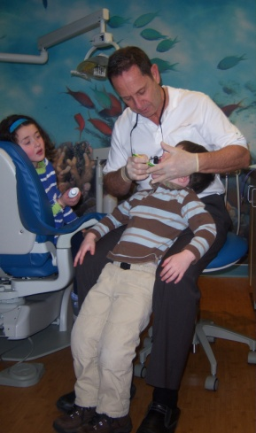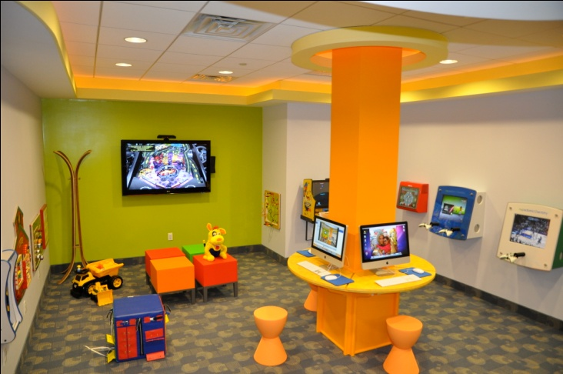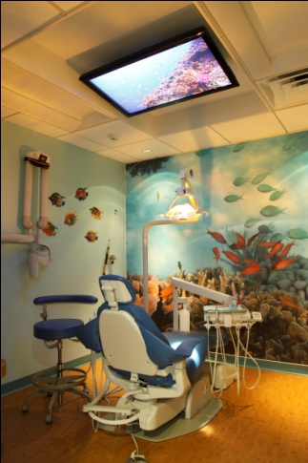
In recognition of February's National Children's Dental Health Month, NY Pediatric Dentistry of Rye Brook will be offering a complimentary oral examination for each family member up to 18 yrs of age, along with an Orthodontic evaluation for each child during the month of February.
A very different dental experience awaits both children and their parents at NY Pediatric Dentistry in Rye Brook. Dr. Louis Cooper, a Harrison resident, has integrated a progressive and unique approach to pediatric dentistry in an engaging environment. A kid’s entertainment area boasts three iMacs, a wall of interactive and educational toddler games and toys along with comfortable stools for seating and viewing movies from a 60-inch TV screen. Parents can relax and enjoy alongside their children in a reception area designed with Wi-Fi and a large-screen TV.
The latest in technological advances are employed, with an emphasis on prevention to reach the goal of having all children part of the ‘cavity free generation”. Those who are anxious about dentistry, medically compromised, or face developmental challenges, care is individualized and delivered with empathy.
Dr. Cooper founded NY Pediatric Dentistry to bring decades of experience as a prominent Manhattan Pediatric Dentist closer to his home in Westchester. Dr. Finn, who provides orthodontic care, completes the total health care needs of the patient, all in one office. Their experience, dedication, and training as specialists in children’s dentistry and orthodontics help in achieving optimal oral healthcare.

Link to website: http://nypediatricdds.com

Click here for exclusive offer to RNNC members

